PROJECT FLOW

|  |  |
| --- | --- |
| Team ID | PNT2022TMID44635 |
| Team Members | 1. Ravichandran.A 2. Chandru.K 3. Vasanth.D 4. Vishnu.S 5. Manikandan.R |
| Project Name | Analytics for Hospital’s Healthcare Data |



USER



IBM CONGNOS



DATASET

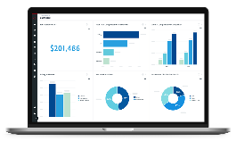

DASH

BOADR



DATA

EXPLORATION

LoS of

Patient

Patients

Severity

Report



DATABASE